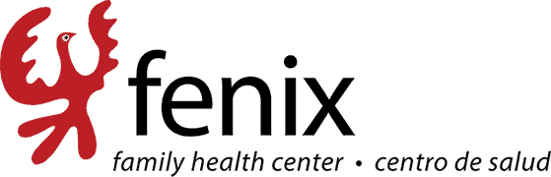

Family Nurse Practitioner Job description

Fenix Family Health Center

We are looking for a Nurse Practitioner who is fluent in Spanish and can offer culturally respectful medical care to the low income and uninsured community. The nurse clinicians will diagnose and treat health conditions, as well as promote good health practices. As an advanced practice registered nurse, you’ll be our go-to person for ensuring the best patient care possible. The job description of a nurse practitioner includes conducting physical examinations, interpreting lab tests and overseeing patients’ health. You’ll be both a health practitioner and an educator, supporting disease prevention practices and helping people lead healthy lives. You should have experience in one of the following Nurse Practitioner specialties: acute care, neonatal care, pediatrics, cardiology, family health, women’s health or psychiatry. Extensive clinical experience on primary care is vital. As a Nurse Practitioner, you’ll have to work closely with other healthcare professionals, so you should have a team spirit and a positive attitude. Patience, problem-solving skills and communication ability are important.

Responsibilities
- Examine patients and their medical records
- Order and study diagnostic tests (blood tests, X-rays etc.)
- Diagnose health conditions and illnesses
- Propose treatments for chronic and infectious diseases
- Prescribe medications
- Maintain accurate records and schedules
- Inform patients about their health conditions and prescribed medications
- Educate patients and their family members on diseases, epidemics and prevention
- Oversee patients’ overall health
- Promote good health practices
- Advance professional knowledge and conduct research if desired.
Skills
- Proven experience(at least 2 years) as Nurse Practitioner in a clinic, hospital, ER or other setting
- Expertise in primary care, acute care and chronic care practices
- Knowledge of health and patient care regulations
- Excellent communication skills
- Strong ethics
- Team spirit with a positive attitude
- Patience and cool-headedness
- Willingness to continue gaining knowledge and clinical experience
- Valid nurse practitioner license
- Master’s degree; DNP is a plus
Job Types: Full-time, Part-time, Contract
Salary: $50.00 - $60.00 per hour

Benefits:
- 401(k)
- Dental insurance
- Flexible schedule
- Health insurance
- Paid time off
Medical specialties:
- Primary Care
- Urgent Care
Standard shift:
- Day shift
- Evening shift
Supplemental pay types:
- Bonus opportunities
- Signing bonus
Weekly schedule:
- 3x12
- 5x8
- Monday to Friday
Work setting:
- Clinic
- In-person
- Outpatient
Experience:
- working as an NP: 2 years (Required)

Language:
- Spanish fluently (Required)
License/Certification:
- Certified Nurse Practitioner (Required)
Work Location: In person

