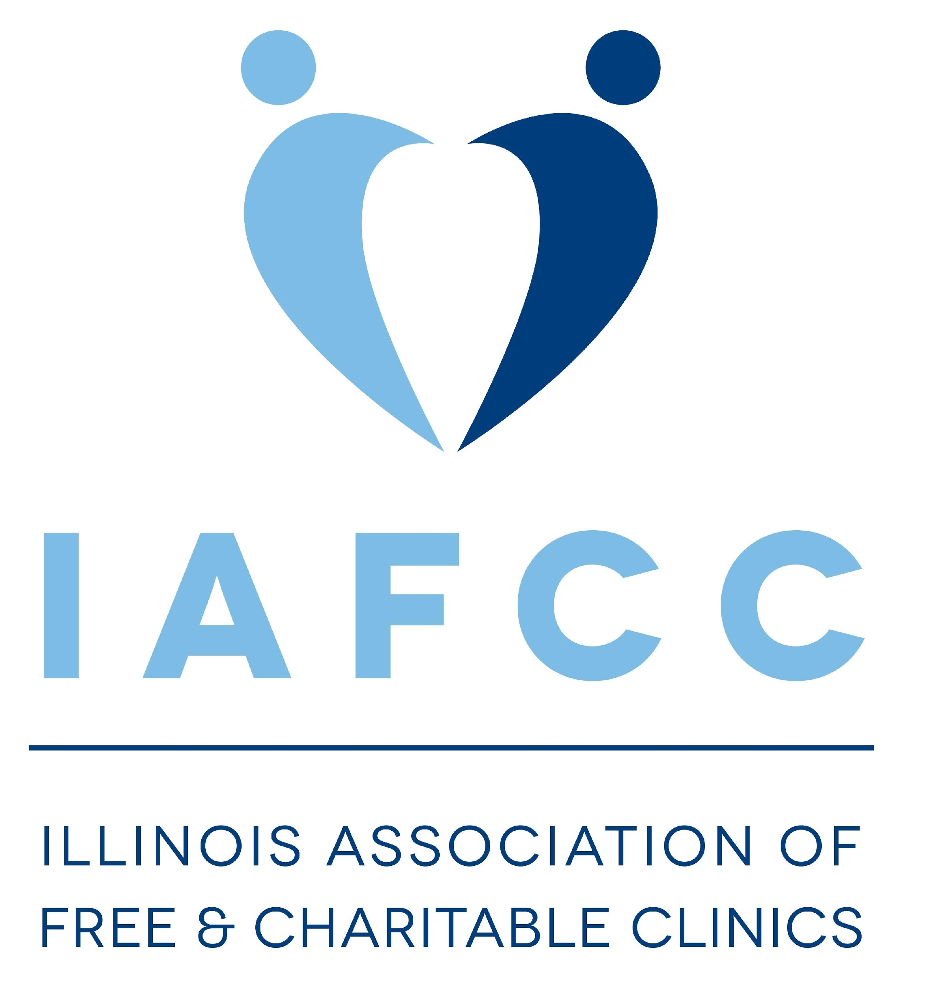
2021 Illinois Association of Free & Charitable Clinics Annual Conference

Illinois Association of Free and Charitable Clinics

10th Annual Conference

New Decade, New Challenges, New Solutions

Monday April 19, 2021- 8:30am-12:30pm

Tuesday April 20, 2021- 1:00pm- 4:30pm

Greetings:

The Illinois Association of Free and Charitable Clinics is excited to host our 10th Annual Conference

This is an opportunity for leaders, staff, volunteers, and community partners of free and charitable clinics to share best practices, stay informed of recent policies, and support each other in the great work of the free and charitable clinic sector. The conference draws participants from around the state of Illinois – bringing together all who make our sector diverse, resilient, and essential.

If you would like to support our conference you can complete the attached form or complete the following link.
https://www.emailmeform.com/builder/form/0zewhLvlp61

Thank you for your support!

2021 Conference Planning Committee

Thank you for your support of the Illinois Association of Free and Charitable Clinics!

SPONSORSHIP AND PROMOTION OPPORTUNITIES

Sponsor Tiers  and Benefits | Conference  Participation | Marketing  Opportunities | Conference  Exposure
Champion  $7,500 | 4 Conference  Registrations | Logo on IAFCC Twitter and Facebook profile banner picture  Logo featured on our website and in conference marketing emails  Logo on promotional items  Social media promotional post for organization  Verbal recognition and logo on opening slide before each session | Logo Featured throughout the conference, before each session and scrolling on the bottom of the page  Logo included in material that is sent to participants
Partner  $5,000 | 3 Conference  Registrations | Website, social media and email recognition  Social media promotional post for organization  Logo on instagram story  Verbal recognition and logo on opening slide before each session | Logo Featured throughout the conference, before each session and scrolling on the bottom of the page  Logo included in material that is sent to participants
Advocate  $2,500 | 2 Conference  Registrations | Website, social media and email recognition  Social media promotional post for organization  Logo on instagram story  Verbal recognition and logo on opening slide before each session | Logo Featured throughout the conference, before each session and scrolling on the bottom of the page  Logo included in material that is sent to participants
Ally  $1,000 | 1 Conference  Registration | Social media recognition  Verbal recognition and logo on opening slide before each session | Logo Featured throughout the conference, before each session and scrolling on the bottom of the page  Logo included in material that is sent to participants
Supporter  $500 | 1 Conference Registration | Social media recognition  Verbal recognition and logo on opening slide before each session | Logo Featured throughout the conference, before each session and scrolling on the bottom of the page  Logo included in material that is sent to participants

Thank you for your support of the Illinois Association of Free and Charitable Clinics!

Sponsor Registration

Please complete this form and email to IAFCC emily@illinoisfreeclinics.org

Upon receipt of your completed form, we will send you a confirmation email with additional details about your participation in the conference.

Organization: __________________________________ Contact Person: ____________________________
Mailing Address: ________________________________ Phone: ____________________
Email: __________________________
+ Sponsor Level & $ Amount: _______________

Signature of Contact Person ______________________________________________

Date_________________________

Payment Information:

The Association is a nonprofit organization, Federal Tax ID #1942444

_______We will be paying by Check: Mail your check made payable to:
Illinois Association of Free and Charitable Clinics

42 Steven St. #416

Lemont, IL 60439

_____ We will be paying by PayPal: Make payment to info@illinoisfreeclinics.org
Please let us know if you would prefer an email invoice through the PayPal system.

Questions or Comments? Contact Melissa Maguire executivedirector@illinoisfreeclinics.org or Emily Slayden at emily@illinoisfreeclinics.org

The above identified organization/business assumes the entire responsibility and liability for losses, damages, and claims arising out of injury to persons or damage to its display, equipment, or other property brought upon the premises and agrees to indemnify, defend, and hold harmless the Illinois Association of Free and Charitable Clinics and its agents and employees.
Thank you for your support of the Illinois Association of Free and Charitable Clinics!

