Consent can be either “opt-out” or “opt-in." HIPAA covered entities and their business associates must have “prior express consent” of the called party before sending them a text message.
Text Messaging in Health Care
Opt-out option would be to simply include a line in your clinic’s Consent for Treatment that patients sign annually. Here is an example: “I hereby give consent to receive auto-dialed or prerecorded messages or texts to my cell phone from or on behalf of Health Care Provider by any affiliates or authorized agents. I can choose to stop this at any time by following instructions given via text or by calling Health Care Provider at #####.”
Opt-in has patient sign a separate consent form. This might be more appropriate if you are planning a more intensive texting program, such as a diabetes management program, in which patients may be receiving several texts per week. Example of an opt-in consent …
Consent to Receive Text Messages from HEALTH SYSTEM
(Member’s non-Lifeline Cell Phone)
By signing below, I authorize HEALTH SYSTEM through its vendor TEXTING SERVICE to contact me by SMS text message to serve me better. HEALTH SYSTEM will send me text messages through the HEALTH SYSTEM member outreach program to help me or my child stay healthy, including:
- timely reminders about needed doctor or dental visits
- how to get help scheduling visits and finding transportation
- tips for keeping my child or teen safe
- information to help manage illnesses

I understand that message/data rates may apply to messages sent through HEALTH SYSTEM to my cell phone and that I may receive up to ## texts per month.
I know that I am under no obligation to authorize HEALTH SYSTEM to send me text messages as part of this program.
I may opt out of receiving these communications from HEALTH SYSTEM at any time by calling HEALTH SYSTEM @ (123) 456-7891 or by texting 'STOP' to 12345.
Name: _______________________________________________________________
Signature: _____________________________________________________________
Date: _____/_______/_______

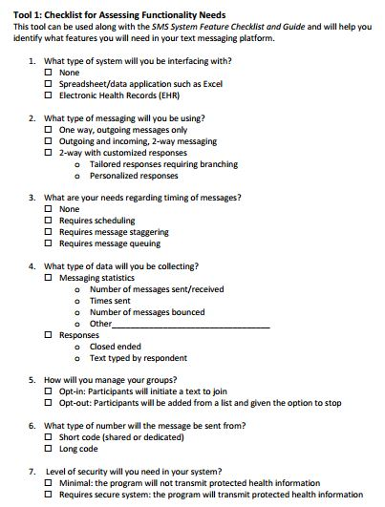
From University of Colorado Denver Center for Research in Implementation Science and Prevention. Center for Care Innovations Texting Toolkit (2013) Retrieved from http://www.careinnovations.org/knowledge-center/texting-for-better-care-toolkit

